**Individual Weekly Report**

**Name: Paul Bae**

**Team:** Good AIM

**Date:** 02/10/2025

| **Current Status** |
| --- |

1. What did you **personally** work on this past week?

| **Task** | **Status** | **Time Spent** |
| --- | --- | --- |
| State Diagrams | Complete | 1 hour |
| Tech Stack installation and research | Complete | 2 Hours |
|  |  |  |

Include **screenshots/graphics** to illustrate what you did this past week:

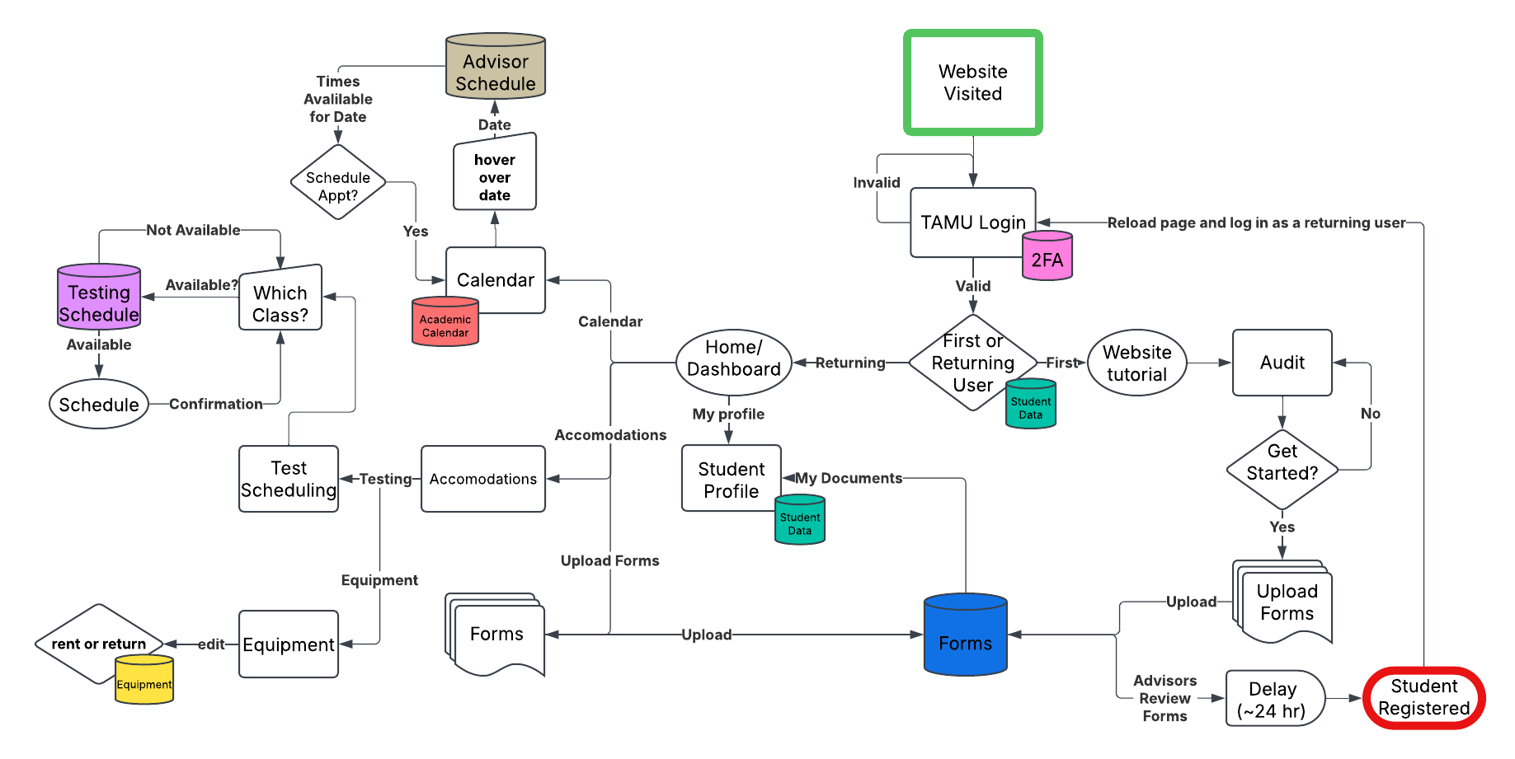

1. What problems did you run into? What is your plan for them?

I was sick on Wednesday, and was not able to come for class. I took extra time to research all of the topics mentioned in class and met with teammates outside of class to fill me in on what I missed

1. What is the current overall project status from your perspective?

We are set up, and are starting on the first batch of user stories, with a sprint scheduled next week.

1. How is your team functioning from your perspective?

The team seems more cohesive now, with more activity in the group chat, and better attendance numbers.

1. What new ideas did you have or skills did you develop this week?

I developed a better understanding of our tech stack and hosting/deployment this week.

1. Who was your most awesome team member this week and why?

Probably Simone, she went out and set up the DB, hosting, and deployment for us!

| **Plans for Next Week** |
| --- |

What are you going to work on this next week?

I have several tasks outlined in our team weekly update, but to name a few, I will do the project report, the individual deep dive, set up dummy data in the database, and create a Staff view for basic modules & global settings in the project.